KIZAD Warehouse

sITE OVERVIEW

**Brief overview**

The Central Warehouse is Located **i**n **Kizad**, wherein Departments like **Supply Chain, Fleet, Pharmacy and Education** operates**.**

|  |  |
| --- | --- |
| **Site Information** | |
| Name | **Kizad Warehouse** |
| Address | **Kizad A8, Industrial Unit # IU01, IU02 & IU03 , Al Samha Abu Dhabi** |
| Contact | **Tarek Alsabagh** |
| Mobile | **0564069542** |
| Landline | **Extension 612** |
| Website | **www.nationalambulance.ae** |
| GPS Coordinates | **24.7100228, 54.7302306** |

MAP

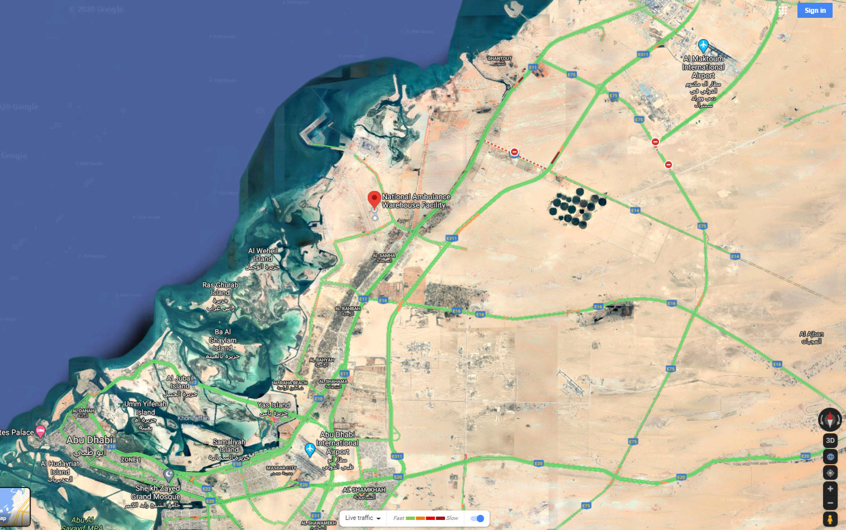

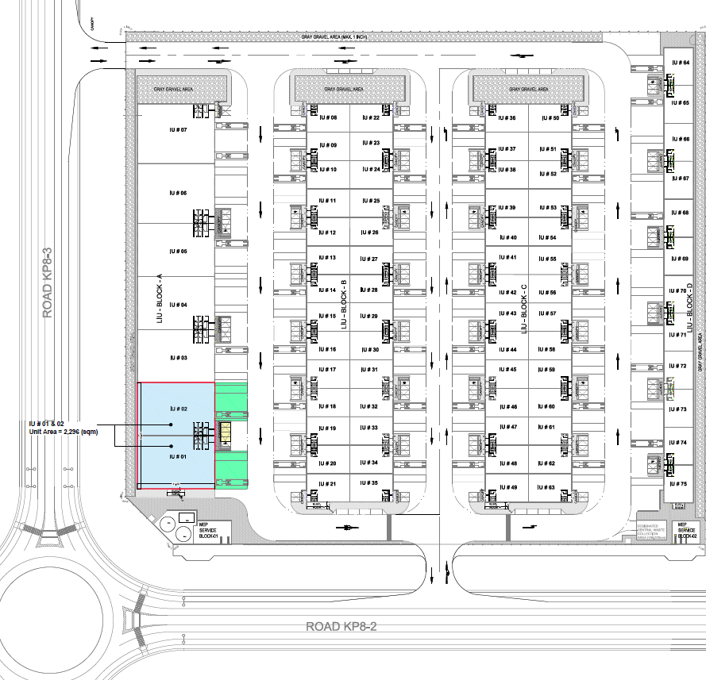

SITE ACCESS

**From Abu Dhbai**

## Abu Dhabi  - Al Shahama Rd/Sheikh Zayed Bin Sultan St/E10 and Sheikh Maktoum Bin Rashid Rd/E11 to 16th St/Al Yal St.

## Exit from Sheikh Maktoum Bin Rashid Rd/E11 Continue on (Al Yal St)

## on the 3r roundabout take 1st exit and drive in (AL SHILLAYLAH ST )

## Continou on (AL SHILLAYLAH ST) and cross first signal and Turn left on second signal to reach ( Al Manteqah As sinaiyah 6th st )

## Drive in (AL Manteqah As sinaiyah 6th ST) and cross first ROUNDABOUT, on your second roundabout take 3 exit on your right to reach ( Bab AL ajwad 1 st )

## drive IN KP8-2( Bab AL ajwad 1 st ) and on first roundabout take first right

## drive IN KP8-3( Al Intifa' St) and Destination will be on the right.

**From Dubai**

## Dubai  - Al Shahama Rd/Sheikh Zayed Bin Sultan St/E10 and Sheikh Maktoum Bin Rashid Rd/E11 to 16th St/Al Yal St.

## Exit from Sheikh Maktoum Bin Rashid Rd/E11 on exit 376C ( KIZAD A – KHLAIFA port ) and Continue on (Al WARQA ST)

## on (Al WARQA ST) take right on the first exit( bridge ) and stop on traffic signal

## Take left on traffic and cross bridge signal and drive in (AL SHILLAYLAH ST )

## Continou on (AL SHILLAYLAH ST) and cross first signal and Turn left on second signal to reach ( Al Manteqah As sinaiyah 6th st )

## Drive in (AL Manteqah As sinaiyah 6th ST) and cross first ROUNDABOUT, on your second roundabout take 3 exit on your right to reach ( Bab AL ajwad 1 st )

## drive IN KP8-2( Bab AL ajwad 1 st ) and on first roundabout take first right

## drive IN KP8-3( Al Intifa' St) and Destination will be on the right.

**Warehouse unit numbers are : IU 01 - IU 02 - IU 03**